**Jenkins and Sonarqube integration with maven project**

Prerequisites:-

1. Latest version of jdk
2. Sonar qube (sonarqube-8.9.1.44547)
3. Sonar scanner (and sonar-scanner-4.6.2.2472-windows)
4. Git, Sourcetree
5. Jenkins latest version

Step 1:- Check available plugins in installed tab, if required install necesory plugins from available tab.

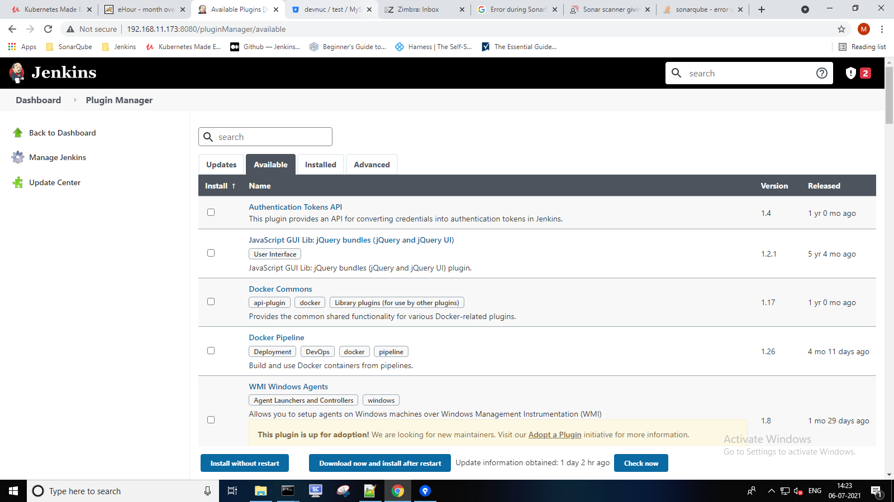

Step2 :-Configure JDK,Git,MAVEN, Sonarqube and Sonarqube scanner path in Global Tool Configuration

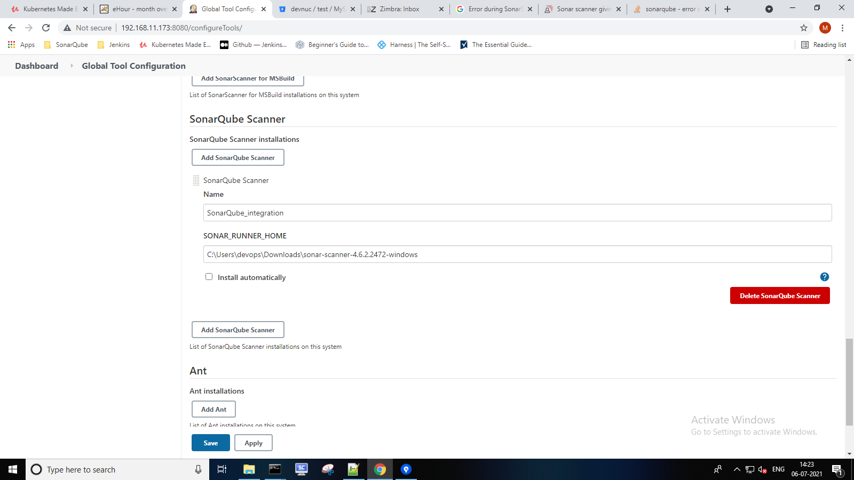

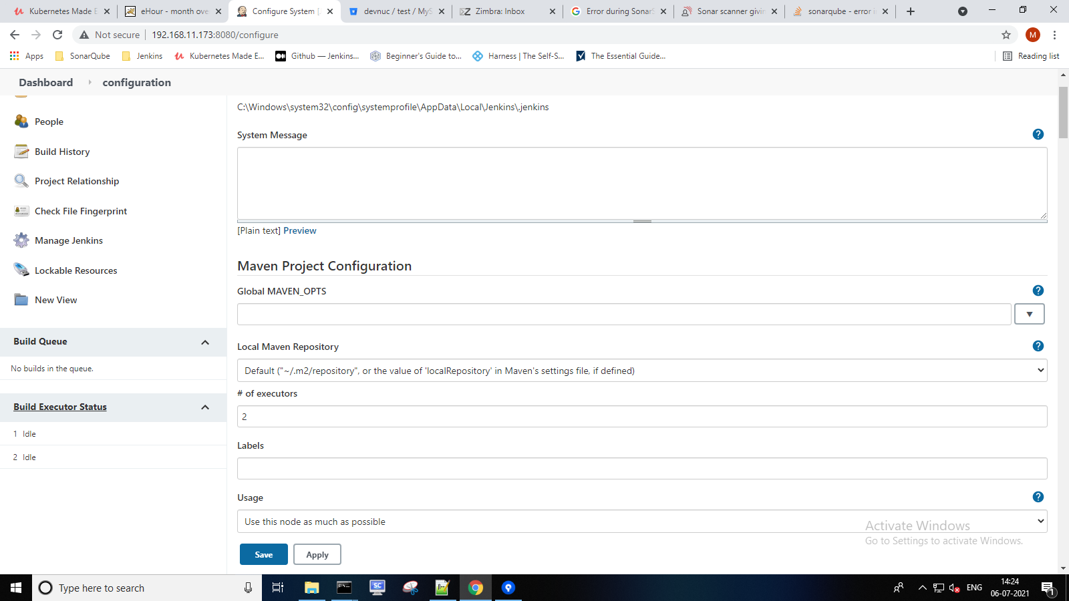

Step 3:- To configure SonarQube server in jenkins we required Server authentication token

1. Goto jenkins ->Manage Jenkins->Configure system
2. Then perform blow steps to generate sonarqube token.
3. Login to sonarqube server url
4. Go to My Account
5. Select user account(Admin) and then go to security tab.
6. Then generate token it will generate unique key

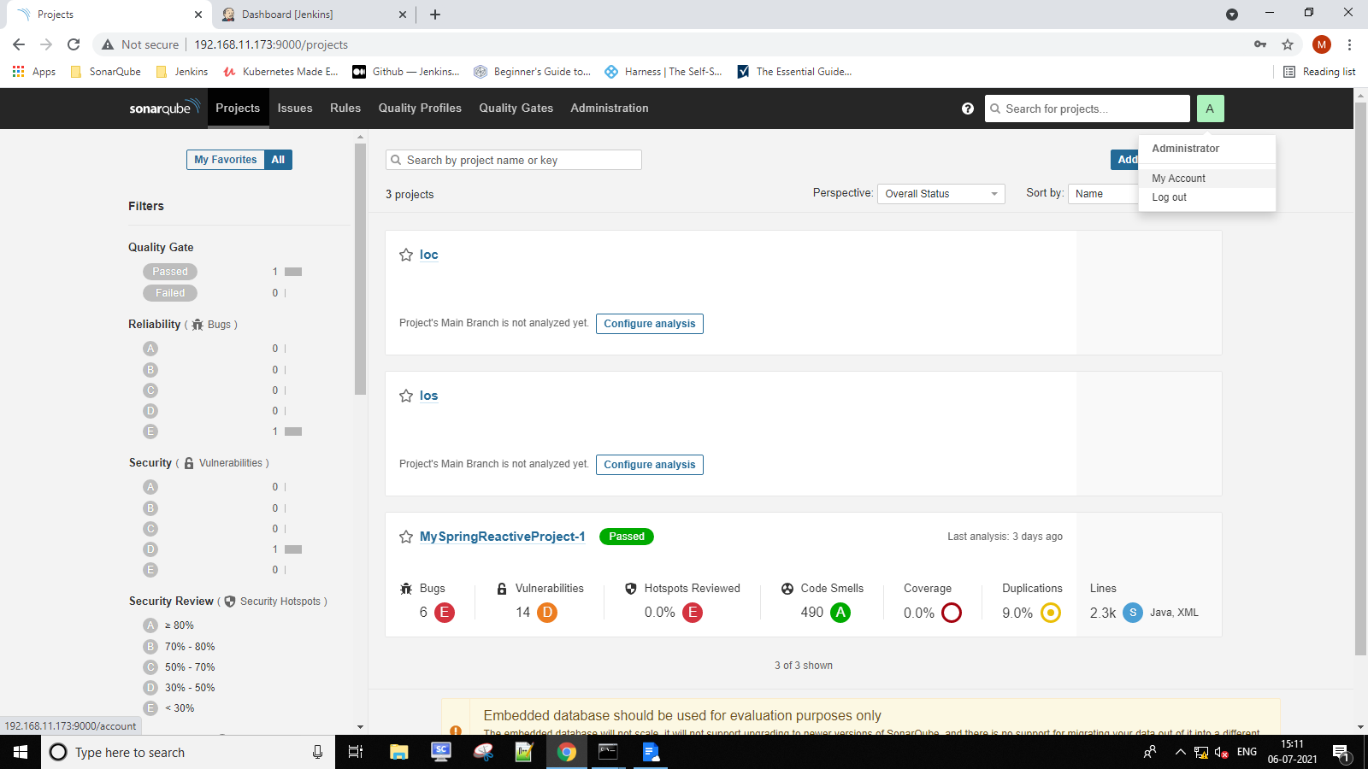

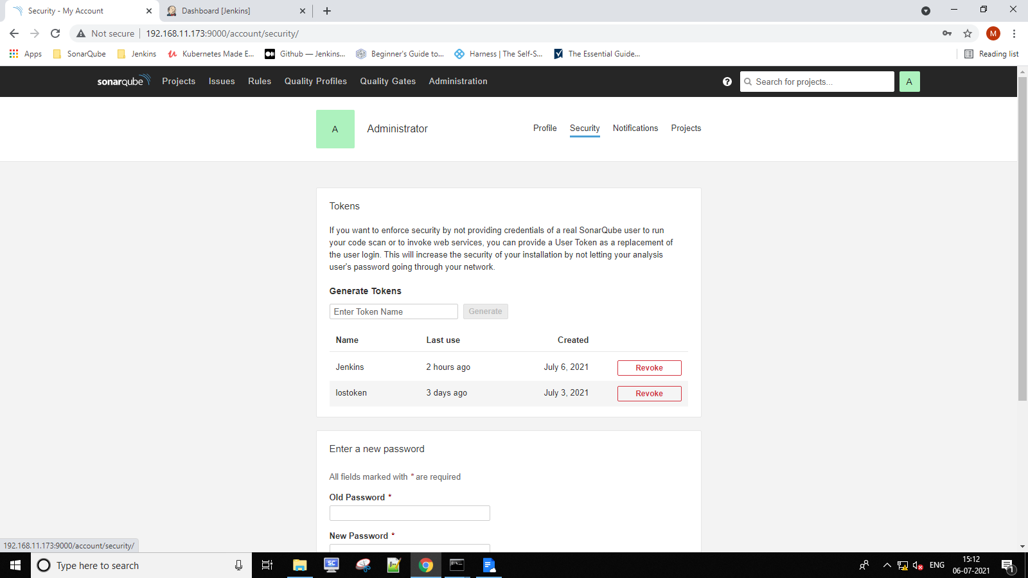

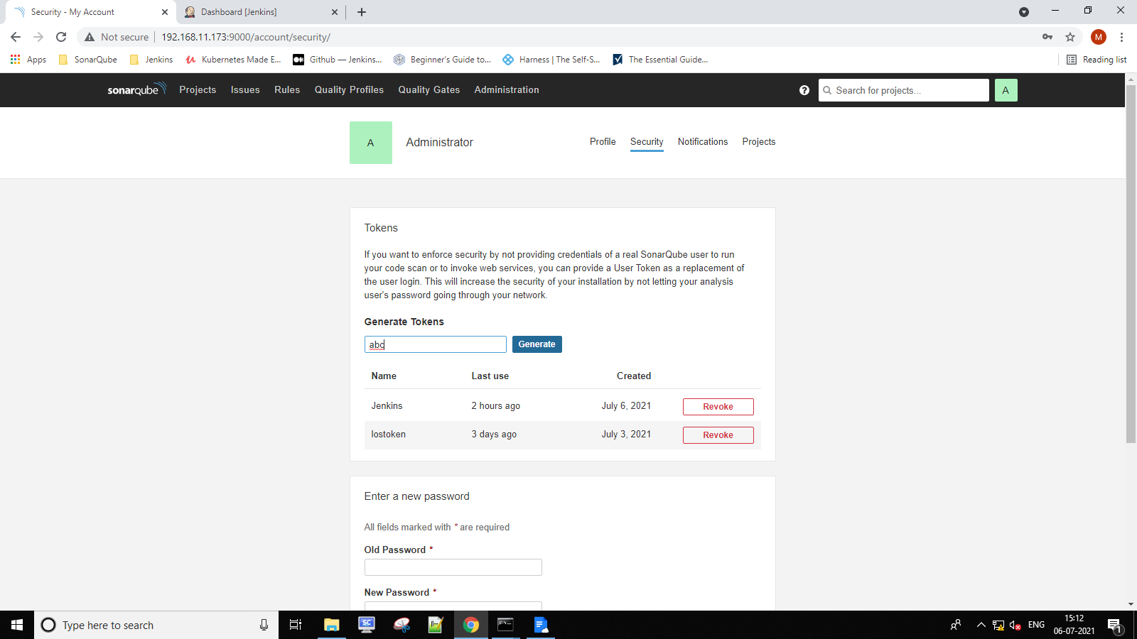

Provide required user(Admin) Execute Analysis permission in sonarqube console

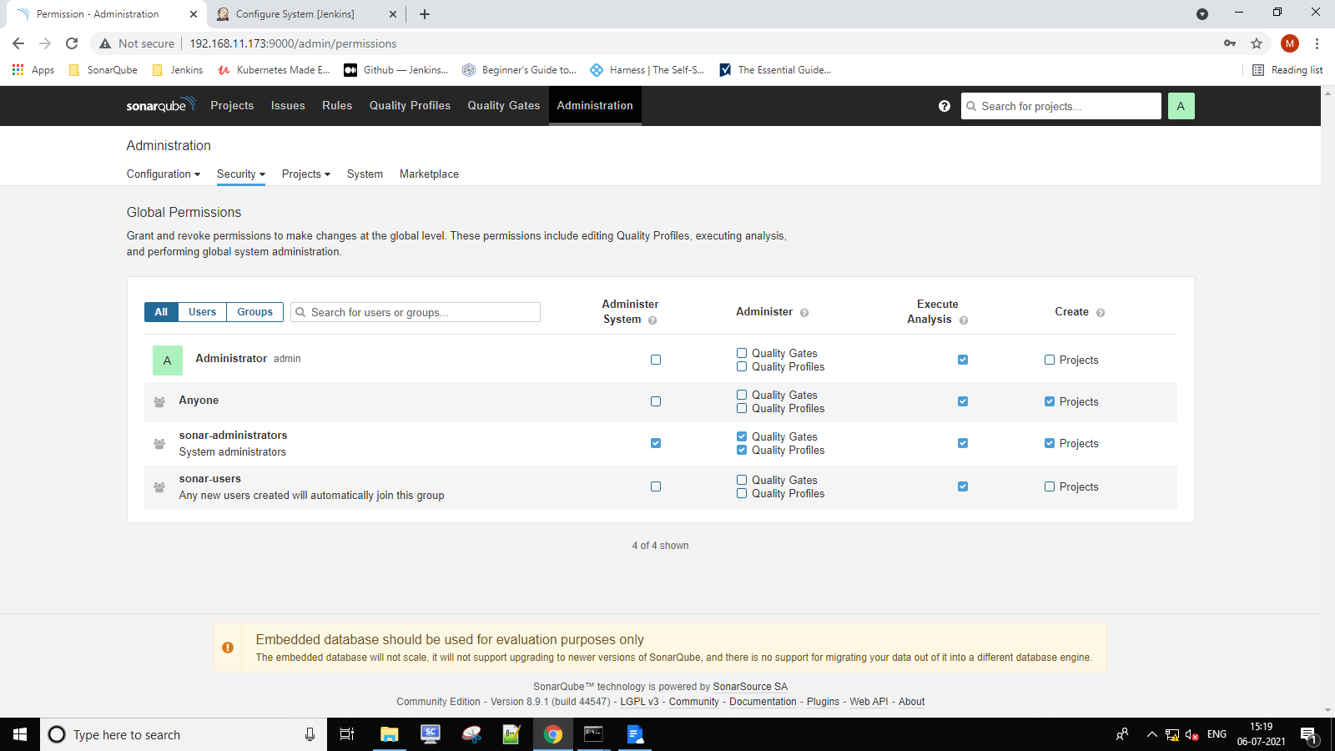

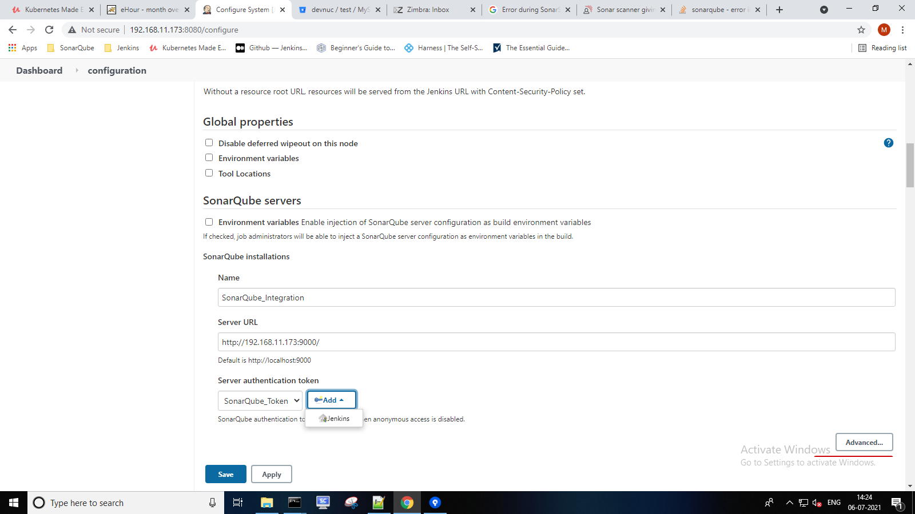

To setup email notification refer below snapshot.

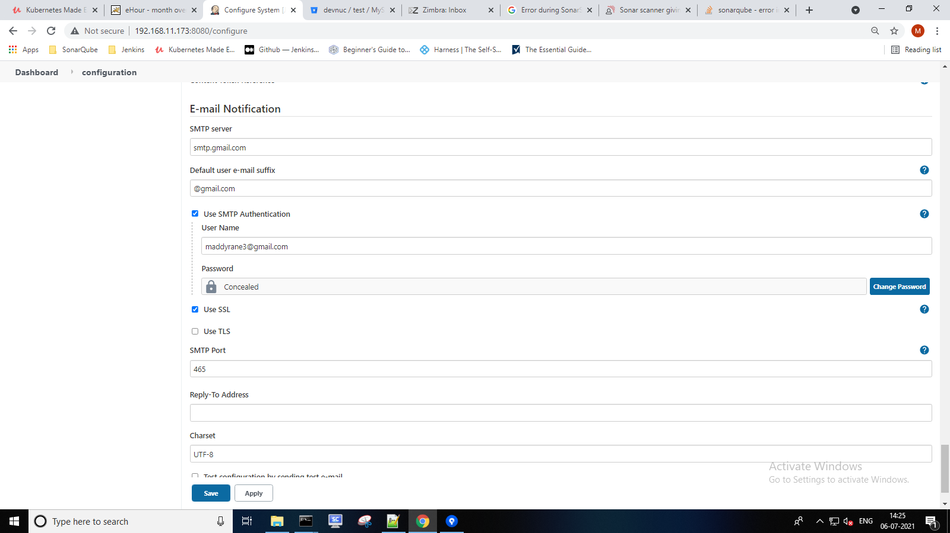

Now we can create Maven project job

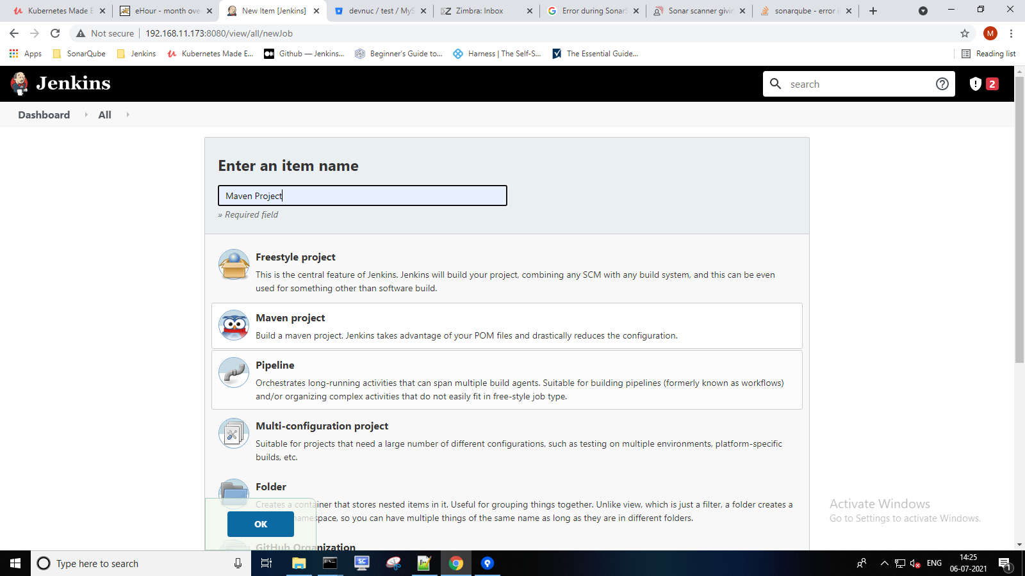

Step 4:- For Source Code Management we use Git and provide repository URL of our bitbucket repo browser.

Repository URL:-https://devnuc@bitbucket.org/devnuc/test.git

Provide credentials as bitbucket user id and password

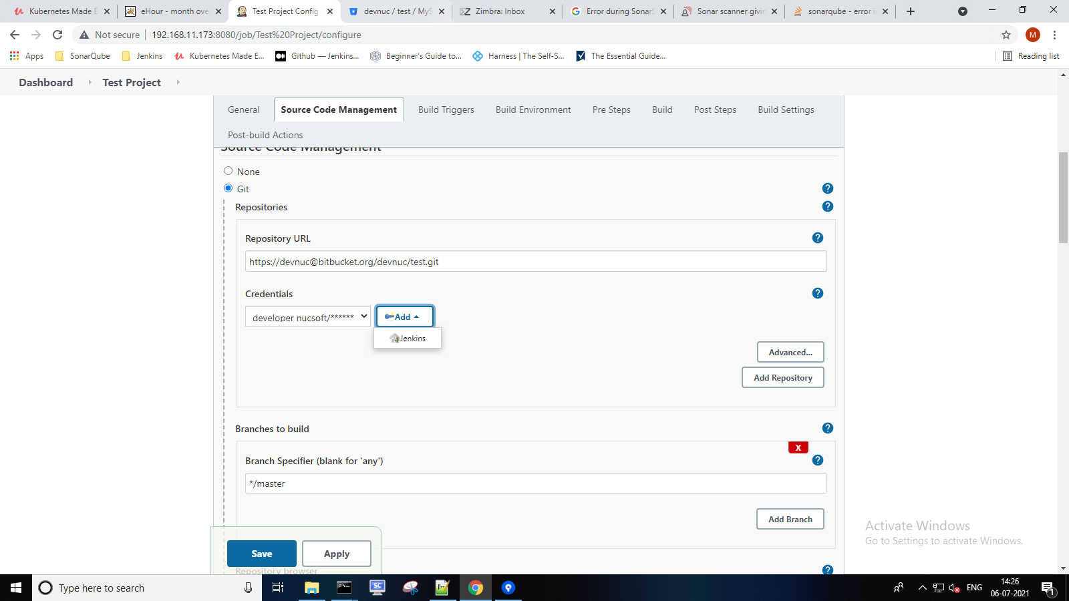

In build Triggers section we select checkbox as Build whenever a SNAPSHOT dependency is built

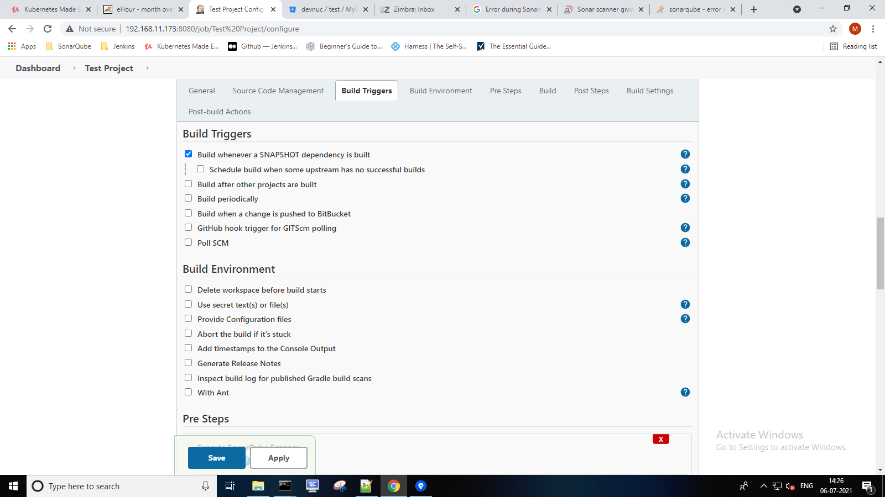

In Pre setps section we add properties in Analysis properties

*sonar.host.url=http://192.168.11.173:9000*

*sonar.projectKey=0e46431a584a44fbb2e0100f3b4fdef98d28b9da*

*sonar.projectName=test-app*

*sonar.sourceEncoding=UTF-8*

*sonar.language=java*

*sonar.sources=MySpringReactiveProject/src/main*

*sonar.java.binaries=.*

*sonar.test=MySpringReactiveProject/src/test*

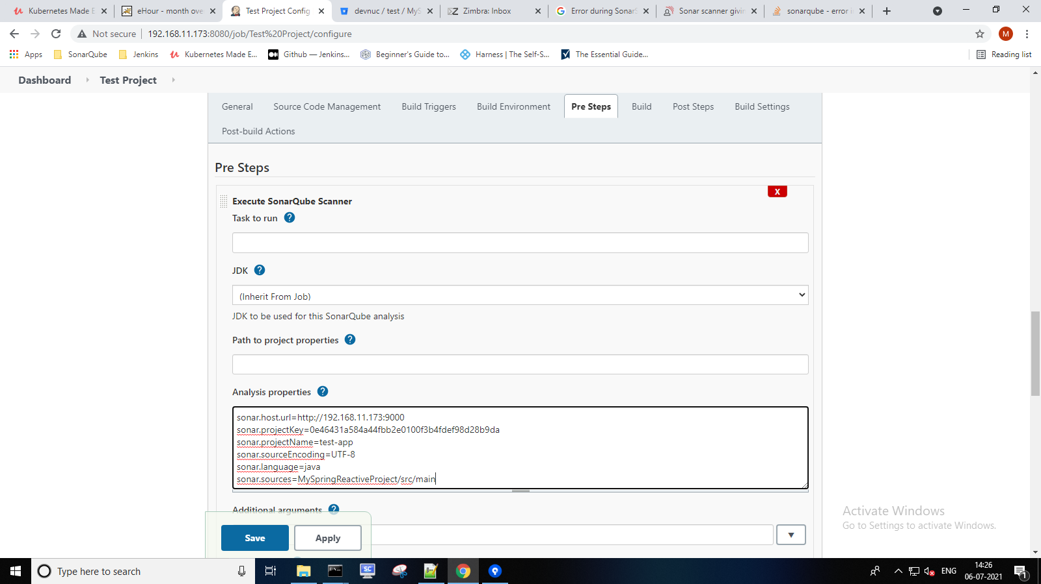

In build section provide POM file path from source code repository

POM path:-MySpringReactiveProject/pom.xml

And then provide Goals and options to trigger commands

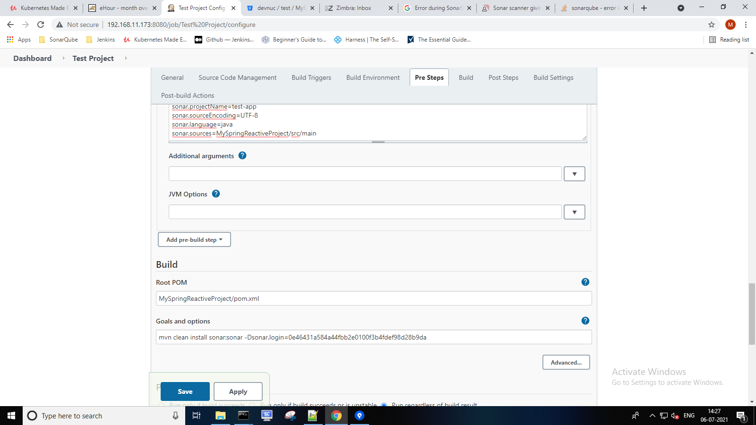

In Build Settings section we can configure E-mail notification as per below snapshot.

